The Ivory Tower’s Force: Transparency, Racial Bias & The University of Chicago Police Department

The University of Chicago Police Department (UCPD) is a force without a public mandate vested with the authority of the state.[1] Within the last decade, UCPD has transformed into one of the nation’s largest private police agencies with more individuals living in its jurisdiction than many mid-sized towns. Yet, UCPD reports only to the leadership of the University of Chicago (UC). The public cannot vote in a new administration to implement different police policies, or even view basic administrative records of the department. In response to a series of public incidents and public safety failures, including the on-campus murder of UC graduate student Amadou Cisse, UCPD now patrols the neighborhoods of twenty five thousand black Chicagoans.[2] This paper studies publicly available information on UCPD, utilizing UCPD’s own data, Freedom of Information Act requests, and theories of police legitimacy. I conduct an original analysis of UCPD’s data which shows that African Americans are significantly more likely to be stopped, searched, and cited than any other racial group. Based on this analysis and UCPD’s recent history, I issue a series of recommendations including the expansion of UCPD’s civilian oversight board to have full jurisdiction over complaints involving racial bias, the improvement of UCPD’s open data to better identify issues of racial bias, and, most critically, the issuance of an annual report by UC which summarizes UCPD data on racial outcomes and any reforms implemented in the last year.

***A brief history of UCPD***

UCPD hired its first formal police chief, Rudy Nimocks, in 1989. Nimocks, a former Chicago Police Department (CPD) Deputy Superintendent who was once on a short list to be CPD superintendent, quickly expanded UCPD’s jurisdiction as “a lot of people who came over into our area to commit crimes…live right next store.”[3] Nimocks also saw UCPD become a fully certified law enforcement agency with patrol cars.[4] UCPD’s expanded presence both on and beyond campus, dramatically increased the number of officer interactions with individuals not affiliated with the university.

In 2013, a series of on campus protests at the University of Chicago Medical Center led to the arrests of students, alumni, and minors. UCPD’s response failed to follow their own procedures.[5] A CPD officer on the scene remarked: “They don’t have the expertise in dealing with crowds…[UCPD] is finally getting a taste of what it means to be police.”[6] A few weeks later, an undercover UCPD detective infiltrated a student campus protest, marching and carrying a sign. After an expose in the Chicago Maroon, UC released the following statement: “The behavior as described is antithetical to the University's values and we will not tolerate it. The University will investigate this expeditiously and take immediate steps to ensure it is not repeated.”[7] After the investigation, the officer’s supervisor was fired, although a resulting wrongful termination lawsuit determined that he was following orders from UCPD’s chief of police and he was awarded $150,000 in damages.[8] Details of this investigation were only released as they were subpoenaed in this suit.[9]

Campus activism continued and, in 2015, the Campaign for Equitable Policing, a group of UC students and community members, launched a legislative campaign to subject UCPD to the same transparency requirements as all other public police forces after such information was repeatedly withheld by UC officials. A bill passed the Illinois House of Representatives which would have required UCPD to “disclose to the public any information that a law enforcement agency would have to disclose under the Freedom of Information Act.”[10] The bill stalled in the Illinois Senate but it spurred UCPD to release more information than legally required for the first time.

In 2018, UCPD officers shot Charles Thomas, a fourth-year UC student, who was in the thralls of a mental health crisis. The student was armed with a metal pipe, but UCPD officers were not equipped with Tasers. Thomas was not killed and is currently jailed on charges related to the incident. In this case, UCPD chose to release body camera footage of the incident.[11] This again spurred reform. In September 2019, UC announced its officers would carry Tasers and complete at least eight hours of risk-minimization public safety effort training as part of new use-of-force rules.[12]

***An Overview of UCPD’s released data***

UCPD releases a variety of data daily on its activities which “goes beyond the requirements…but is provided as a way to enhance the transparency of our policing activities.”[13] UCPD releases data on traffic stops initiated by the department, crimes and fires which occur in the UCPD patrol area, and field interviews conducted by UCPD officers. Many of these data sets include information on race and outcomes (such as cited, arrested, no action). A complete analysis is available in Appendix 1. Data from 2015 through December 2019 was acquired.

The data has two main takeaways: African Americans are stopped more often and face more severe outcomes when stopped than any other ethnic group. Even though only 50% of residents in UCPD’s patrol area are African American, in 2019, about 75% of UCPD traffic stops and 98% of interviews were with African Americans.

During traffic stops, African Americans received a citation 13.6% of the time, a rate more than double the Caucasian citation rate of 6.1%. African Americans are also searched at more than five times the rates of Caucasians, with almost 95% of all vehicle searches conducted by UCPD on African Americans.[14] Half of searches conducted on African American drivers ended without a citation. In 2019, the disparities were even starker. 34 out of 35 traffic stop searches were conducted on African American drivers, with about 2/3rds of these searches ending in no citation. Citation rates for Caucasians and African Americans dropped from previous years, but African Americans were still cited at over 2.5 times the rates of Caucasians. Interview outcomes differ as well. African Americans were searched at higher rates and during one six month stretch from September 2016 to March 2017 UCPD only interviewed African Americans.

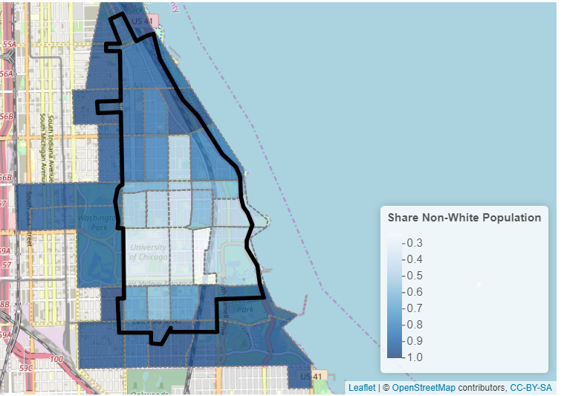

**Figure 1: UCPD’s Patrol Area (highlighted in black) which includes more than 50,000 residents. Darker blue areas are predominantly African American communities, who consist of about 50% of the patrol area’s residents.**

UCPD also releases some of its general orders, its procedures and policies. About a dozen of these orders are not released to the public including orders on UCPD’s License Plate Recognition System and VIP security policies. UCPD officers do wear body cameras, but copies of the recordings will only be released to valid subpoenas and law enforcement agencies.[15] UCPD can unilaterally decide to release the recordings to the public, as they did in the 2018 Thomas shooting.

UCPD also allows the public to go on ridealongs. I was able to go on a ridealong and to speak with an officer about UCPD’s current policies. The officer highlighted how recent accusations of racial profiling necessitated a fundamental shift in how the UCPD polices predominantly black communities. UCPD now minimizes contact with the public, for example sitting in their car by suspicious individuals instead of stopping and frisking them. UCPD also now typically does not initiate a traffic stop unless the situation could be dangerous to a pedestrian. The officer described his approach to policing his beat as placing individuals into two categories: “students and criminals.”

The final aspect of UCPD’s transparency efforts include the Independent Review Committee (IRC). The IRC reviews complaints filed against UCPD officers and makes nonbinding recommendations or suggestions regarding the outcome of UCPD investigations. UCPD’s complaints process is non-public, meaning that IRC reports are the only data available on complaints filed against UCPD. From March 2005 to June 2018, 166 complaints were made against UCPD officers with the majority of complaints filed by Black Males unaffiliated with UC. These complaints led to 277 findings of which 66 were sustained, a sustainment rate of 24%.[16] Over approximately the same time period and geographic area, CPD received 750 complaints with a sustainment rate of 6.6%.[17]

I additionally submitted multiple Freedom of Information Act requests to public agencies which oversee, partner, or certify UCPD. The Law Enforcement Training and Standards Board supplied information on UCPD’s current officers. UCPD has 93 certified officers of which 52 are African American, 1 is Asian, 28 are Caucasian, and 12 are Hispanic. 14 of UCPD’s officers identify as Female and 79 identify as Male. 60 of the officers have worked at UCPD for less than 10 years.

I have submitted, but have not yet received an adequate response on requests for information regarding any agreements between CPD and UCPD and copies of CPD records which mention UCPD. One of the core questions I look to explore is how, if at all, CPD’s consent decree will affect UCPD.

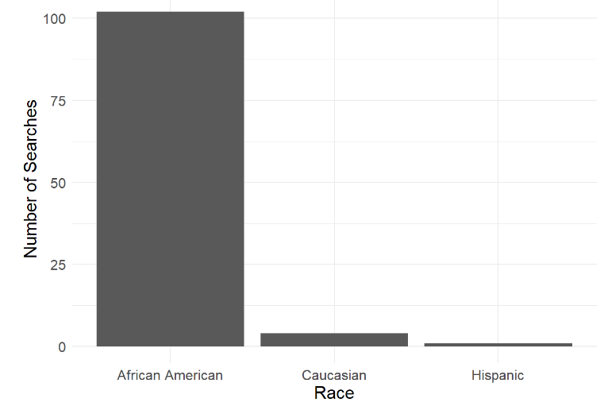

**Figure 2: Number of Interviewees Searched by UCPD between 2015 and 2019. The vast majority of searches were conducted on African American subjects.**

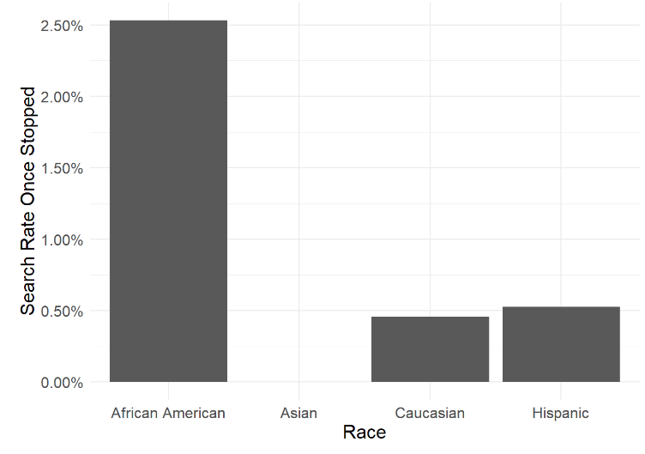

**Figure 3: UCPD’s Traffic Stop search rate from 2015 to 2019. African American drivers are 5 times more likely to be searched than any other racial group. UCPD searches 1 out of 40 African American motorists it stops and 1 out of 218 Caucasian motorists.**

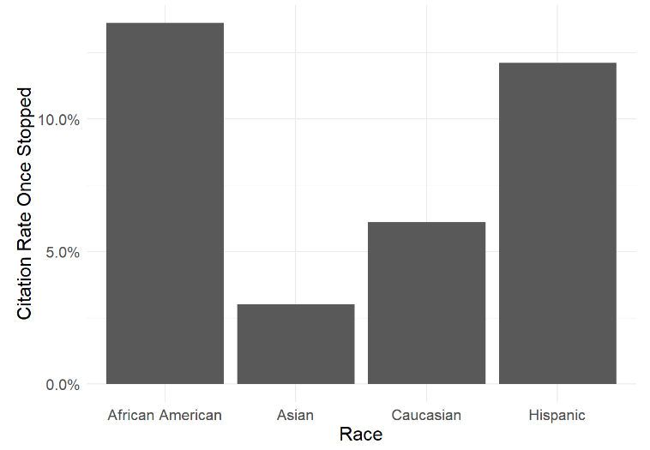

**Figure 4: UCPD Traffic Stop Citation Rate between 2015 and 2019. African American motorists were cited at more than twice the rate of Caucasians.**

***Analyzing UCPD transparency***

UCPD General Order 516 on biased policing is designed to “establish policies and procedures regarding the Department’s commitment to unbiased, equitable treatment of all persons while enforcing the law.” Noting that “public trust and confidence in the police is critical to effective policing,” this order lays out how UCPD will treat all equally regardless of their background in order to avoid biased policing. UCPD’s own data raises serious questions of how effectively this policy is implemented. Even if more African Americans are inadvertently stopped, it is unclear why African Americans would be cited at twice the rate and searched at five times the rate of Caucasians.

While many public events spurred department reforms (such as the 2018 shooting of Thomas), UCPD and UC have long been accused of racial bias in the communities which surround its campus. Using the number of complaints filed against the department as a heuristic, many community members disagree with their treatment at the hands of UCPD, at rates similar to CPD. Unlike CPD though, their complaints against UCPD are kept secret and the lone accountability measure, the IRC, is controlled by UC’s provost. An unaffiliated citizen has no ability to interpret the “university’s values,” leaving many community members unsure of what laws UCPD might enforce on their block.[18] It stands that disparate traffic stop outcomes and a secretive complaint process is against the “community’s values,” especially in light of the numerous oversight agencies Chicagoans have demanded oversee CPD. Most poignantly, African Americans have filed the majority of complaints, received the majority of traffic citations, and experienced the majority of searches since 2015.

***UCPD Constituents***

UCPD has two primary groups of constituents: those affiliated with the university and those who simply live by the university. For those affiliated with UC, it appears both that UCPD is viewed as legitimate and that UCPD is highly responsive to their concerns. The department has consistently and quickly reformed in response to crimes committed against UC students or UCPD actions against campus community members. After the undercover officer incident of 2013, a key catalyst for present-day department transparency, the provost responded by stating that UCPD did not uphold the “university’s values” and reforms were quickly implemented, including the firing of the supervising officer within two months. Similarly, UCPD officers noticeably lacked Tasers in the 2018 shooting of Thomas, which were a viable less lethal option as UCPD officers identified Thomas as a “mental” before the shooting. Within a year, UCPD officers were trained and equipped with Tasers. To this extent, UCPD may be more willing to quickly reform than public police departments because the police themselves do not speak for the department, administrators do. UCPD has been less receptive to student protests which challenge its legitimacy. Recently, student protestors associated with #CareNotCops have called on UCPD to disarm, shrink its jurisdiction, and to shift funding to other community resources, like mental health services.[19]

For community members, opinion is more mixed with some viewing UCPD as a welcome investment in their communities and others viewing them as an unaccountable force which racially profiles them. There is some evidence that UCPD is an effective investment in the communities which surround the university. A recent study found that areas just outside of UCPD’s patrol area experienced 55 percent more overall crime and 63 percent more violent crime, or that UCPD’s patrol area experienced less crime than areas which UCPD did not patrol.[20] The study also suggested that UCPD simply displaces crime into the neighborhoods surrounding its jurisdiction instead of preventing it outright.

***UCPD Legitimacy***

Is UCPD legitimate? Considering that UCPD is a private police department and lacks a public mandate (which suggests that it inherently lacks legitimacy in the sense that CPD might be legitimate), I propose another framework of analysis. Does UCPD offer a net benefit to the communities it polices which would not otherwise be offered by public police departments? Malcolm Sparrow lays out a series of criteria with which to evaluate the benefits and risks of private police departments. Sparrow suggests that benefits include public-private partnerships (of which UC has entered into with the City of Chicago), more effective community policing (for example UC’s Office of Civic Engagement), and greater equity in protection (reduced crime in the UCPD patrol area). Sparrow also outlines risks which include lack of accountability (for example UCPD’s complaint process), threats to public safety (the 2018 shooting of Thomas), loss of “stateness” (how “university values” are converted into policing actions), and greater inequality in protection (overpolicing black motorists).[21] The benefits are seemingly highly valued by the City of Chicago and many community residents as UCPD’s jurisdiction has continually expanded over the past two decades. UC’s community-oriented investments such as charter schools and UC’s level 1 trauma center also benefit community public safety. Ultimately, though, the risks are too significant to be dismissed outright. The centering of “university values” at the core of UCPD’s policing mission means that community members cannot ascertain what UCPD will police without understanding these values. Recent data from UCPD suggests that African Americans either are violating these values at significantly greater rates than Caucasians, or, perhaps, that these values somehow demand greater policing of African Americans.

***Conclusion***

Sparrow notes that “on issues of safety… the interests of public police and the private interests of the university are almost perfectly aligned. Less crime is good for everybody,” but on issues of transparency “interests diverge markedly…[as the university] has a natural and strong interest in painting a rosy picture.” UCPD has recently dramatically increased transparency of its methods, but more work is needed. For the public to ascertain UCPD’s legitimacy, UCPD should take the following actions:

First, to release traffic stop and interview data which includes unique identifiers for UCPD officers. This will allow the public to identify if individual officers cite, search, or arrest African Americans at higher rates than other officers, similar to how the IRC anonymously identifies the number of officers with multiple complaints.

Second, to completely release the rules and procedures for UCPD’s internal review and discipline procedure process. While the IRC is a valid form of transparency, UC essentially only releases information about the IRC and not about the UCPD internal process, even though this process is the one which makes the actual determination.[22]

Third, to give the IRC full jurisdiction over all complaints involving accusations of racial bias and to conduct a full, public audit of all past complaints involving accusations of racial bias. The analysis presented here raises serious questions about racial bias in UCPD. It is entirely possible that some or all of the data identified as biased could be explained by factors unknown to the public. This necessitates a public facing, holistic review of this specific aspect of the UCPD complaints process.[23] Additionally, the appearance of racial bias alone can be critically damaging to a department’s legitimacy. It is unknown how UCPD evaluates complaints involving racial bias or how it has in the past. The involvement of the IRC is then necessary to establish credibility over the review.

Fourth, to undertake annual transparency reports of racial bias in UCPD. Even if racial bias is inadvertent due to other factors not captured in this analysis, the appearance of such disparate racial outcomes in UCPD’s data necessitates formal and consistent attention from UC if UCPD is to be legitimate when policing African American non-affiliates. The continued reevaluation of issues around race and the department, in a public facing manner, will allow UCPD to enter into dialogue with community members and to ultimately create a more effective department. Additionally, an annual report could highlight community policing or positive interactions between UCPD and community members which would otherwise go unnoticed.

In conclusion, African Americans are stopped, cited, and searched at rates significantly higher than all other groups. While UCPD is highly responsive to campus issues, one could reasonably argue, especially in light of the inequitable history of policing in Chicago, that campus safety cannot perpetually be sustained by unjustly overpolicing the university’s black neighbors. Explanations and solutions may very well exist, but first UCPD must continue its transparency reforms to include issues of racial bias.

# Appendix 1: University of Chicago Police Department Open Data Analysis

# 1 Introduction

UCPD releases three types of data on their data page. This data is not directly downloadable and was web scraped into a database which was then standardized. The three types of data include [*The Daily Incident Report*](https://incidentreports.uchicago.edu/), which includes crimes and fires reported to UCPD in its patrol area, [*Traffic Stops*](https://incidentreports.uchicago.edu/trafficStops.php), and [*Field Interviews*](https://incidentreports.uchicago.edu/fieldInterviews.php).

Note that 2019 numbers are through December 6, 2019.

## 1.1 Number of interactions with UCPD by Year

|  |  |  |
| --- | --- | --- |
| **Table 1: Traffic Stops** | | |
| **Year** | **Total** | **% African American** |
| 2015 | 53 | 69.8% |
| 2016 | 342 | 72.2% |
| 2017 | 609 | 71.1% |
| 2018 | 1654 | 72.9% |
| 2019 | 1333 | 75.7% |

|  |  |
| --- | --- |
| **Table 2: Incidents** | |
| **Year** | **Total** |
| 2015 | 337 |
| 2016 | 1096 |
| 2017 | 1104 |
| 2018 | 1246 |
| 2019 | 1166 |

|  |  |  |
| --- | --- | --- |
| **Table 3: Interviews** | | |
| **Year** | **Total** | **% African American** |
| 2015 | 71 | 90.1% |
| 2016 | 77 | 88.3% |
| 2017 | 101 | 96.0% |
| 2018 | 236 | 94.1% |
| 2019 | 122 | 97.5% |

|  |  |  |
| --- | --- | --- |
|  |  |  |

## 1.2 Traffic Outcomes

|  |  |  |  |
| --- | --- | --- | --- |
| **Table 4: Traffic Outcomes** | | | |
| **Year** | **Citation** | **Warning** | **Arrest** |
| 2015 | 5 | 48 | 0 |
| 2016 | 41 | 296 | 5 |
| 2017 | 97 | 511 | 1 |
| 2018 | 198 | 1456 | 0 |
| 2019 | 126 | 1207 | 0 |

|  |  |  |  |
| --- | --- | --- | --- |
| **Table 5: Traffic Outcome by Race** | | | |
| **Disposition** | **Race** | **Total** | **Share in Category** |
| Citation | African American | 398 | 13.6% |
| Citation | Asian | 6 | 3.0% |
| Citation | Caucasian | 40 | 6.1% |
| Citation | Hispanic | 23 | 12.1% |
| Warning | African American | 2526 | 86.4% |
| Warning | Asian | 194 | 97.0% |
| Warning | Caucasian | 615 | 93.9% |
| Warning | Hispanic | 167 | 87.9% |

|  |  |  |  |
| --- | --- | --- | --- |
| **Table 6: Traffic Search Outcomes by Race** | | | |
| **Search** | **Race** | **Total** | **Share in Category** |
| No | African American | 2850 | 97.5% |
| No | Asian | 200 | 100.0% |
| No | Caucasian | 652 | 99.5% |
| No | Hispanic | 189 | 99.5% |
| Yes | African American | 74 | 2.5% |
| Yes | Caucasian | 3 | 0.5% |
| Yes | Hispanic | 1 | 0.5% |

|  |  |  |  |  |
| --- | --- | --- | --- | --- |
| **Table 7: Traffic Violation Outcomes by Race** | | | | |
| **IDOT Classification** | **African American** | **Asian** | **Caucasian** | **Hispanic** |
| Equipment | 6.4% | 3.0% | 5.3% | 8.9% |
| Lane Violation | 21.6% | 22.5% | 29.6% | 23.2% |
| license plate/registration | 1.2% | 1.0% | 0.6% | 1.1% |
| moving violation | 6.2% | 6.0% | 5.8% | 4.7% |
| speed | 4.8% | 2.0% | 2.4% | 1.6% |
| Traffic Sign/Signal | 60.0% | 65.5% | 56.2% | 60.5% |

|  |  |  |  |  |  |  |  |  |  |
| --- | --- | --- | --- | --- | --- | --- | --- | --- | --- |
| **Table 8: Traffic Stop Outcomes by Race and Year** | | | | | | | | | |
| **Year** | **Race** | **Percent Searched** | | **Percent Cited** | **Searched & Cited** | **Searched & Not Cited** | **Warning** | **Count** | |
| 2015 | African American | | 3% | 8% | 0% | 3% | 92% | | 36 |
| 2015 | Asian | | 0% | 0% | 0% | 0% | 100% | | 2 |
| 2015 | Caucasian | | 0% | 18% | 0% | 0% | 82% | | 11 |
| 2015 | Hispanic | | 0% | 0% | 0% | 0% | 100% | | 2 |
| 2016 | African American | | 0% | 14.88% | 0% | 0% | 85.12% | | 242 |
| 2016 | Asian | | 0% | 0.00% | 0% | 0% | 100.00% | | 15 |
| 2016 | Caucasian | | 0% | 6.25% | 0% | 0% | 93.75% | | 64 |
| 2016 | Hispanic | | 0% | 7.14% | 0% | 0% | 92.86% | | 14 |
| 2017 | African American | | 1% | 18.1% | 0% | 0% | 81.9% | | 432 |
| 2017 | Asian | | 0% | 6.8% | 0% | 0% | 93.2% | | 44 |
| 2017 | Caucasian | | 0% | 9.4% | 0% | 0% | 90.6% | | 106 |
| 2017 | Hispanic | | 4% | 26.1% | 4% | 0% | 73.9% | | 23 |
| 2018 | African American | | 3% | 14.2% | 2% | 1% | 85.8% | | 1205 |
| 2018 | Asian | | 0% | 0.0% | 0% | 0% | 100.0% | | 87 |
| 2018 | Caucasian | | 1% | 5.9% | 1% | 0% | 94.1% | | 256 |
| 2018 | Hispanic | | 0% | 11.9% | 0% | 0% | 88.1% | | 101 |
| 2019 | African American | | 3% | 10.9% | 1% | 2% | 89.1% | | 1009 |
| 2019 | Asian | | 0% | 5.8% | 0% | 0% | 94.2% | | 52 |
| 2019 | Caucasian | | 0% | 4.1% | 0% | 0% | 95.9% | | 218 |
| 2019 | Hispanic | | 0% | 8.0% | 0% | 0% | 92.0% | | 50 |

## 1.3 Interview Outcomes

|  |  |  |  |
| --- | --- | --- | --- |
| **Table 9: Interview Search Outcomes by Race** | | | |
| **Search** | **Race** | **Total** | **Share in Category** |
| No | African American | 468 | 82.1% |
| No | Caucasian | 23 | 85.2% |
| Yes | African American | 102 | 17.9% |
| Yes | Caucasian | 4 | 14.8% |

|  |  |  |
| --- | --- | --- |
| Table 10: Interview Disposition Outcomes by Race | | |
| **Disposition** | **African American** | **Caucasian** |
| arrested | 3.5% | 0% |
| Name Checked/Other | 2.1% | 14.8% |
| referred | 2.3% | 3.7% |
| released | 92.1% | 81.5% |

## 1.4 Incident Outcomes

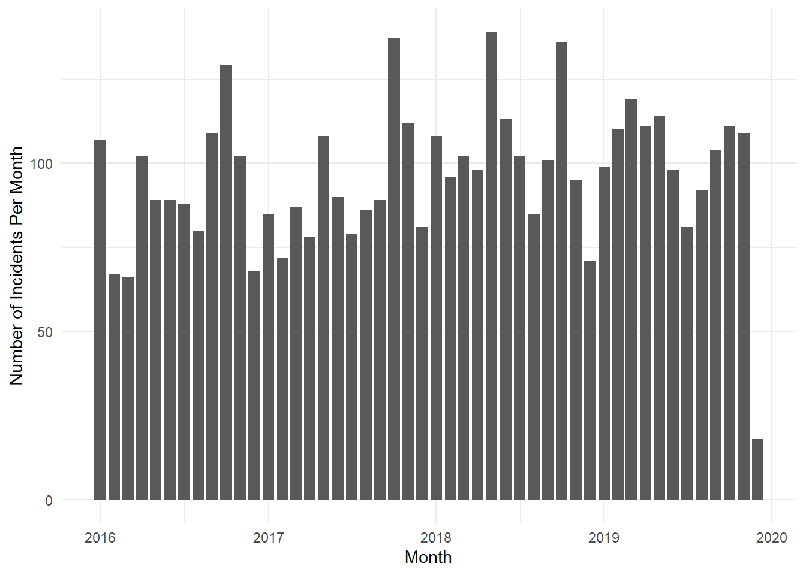

## 1.5 Gaps

For over half a year from 9/17/2016 to 3/10/2017, UCPD only interviewed African Americans.

# 2 UCPD Patrol Area

| Table 11: Population in Census Tracts which intersect UCPD Patrol Area | | |
| --- | --- | --- |
| **Total Population** | **Total White Population** | **Total Black Population** |
| 83303 | 20200 | 53244 |

| Table 12: Projected Population in UCPD Patrol Area | | |
| --- | --- | --- |
| **Total Population** | **Total White Population** | **Total Black Population** |
| 53726 | 18163 | 27270 |

## 2.1 Github Directory

## The code and an html version of this appendix is available online: <https://github.com/erhla/UCPD>

1. UCPD is vested with the powers of “municipal peace officers and county sheriffs” by the Illinois Legislature. *Private College Campus Police Act of 1992.*
2. Report of the Campus Safety and Security Committee; https://safety-security.uchicago.edu/news/report_of_the_campus_safety_and_security_committee/
3. “Signs point to Nimcoks as Top Cop,” *Chicago Tribune*, 9/1/1987.
4. “A brief history of the UCPD,” *Chicago Maroon*, 5/25/2012.
5. A University affiliate requested the Dean-on-Call, an administrator whose role it is to interface between affiliates and UCPD. UCPD did not quickly facilitate this request.
6. “UCMC protests, four arrests prompt rapid response from supporters,” *Chicago Maroon*, 1/29/2013.
7. “Undercover UCPD detective infiltrates protest,” *Chicago Maroon*, 3/1/2013.
8. Owens v. University of Chicago. https://casetext.com/case/owens-v-univ-of-chi
9. “The Fight Over Chicago’s Largest Private Police Force,” *South Side Weekly*, 7/16/2018.
10. “The Fight Over Chicago’s Largest Private Police Force,” *South Side Weekly*, 7/16/2018.
11. “UCPD Office Shoots U of C Student Wielding Metal Pole, Smashing Windows,” *Chicago Maroon*, 4/4/2018.
12. “UCPD sets out use-of-force rules; officers will be issued Tasers*,” Hyde Park Herald*, 9/4/2019.
13. UCPD is required to release a variety of information under the Clery Act, which requires universities to report crimes around their campuses. https://safety-security.uchicago.edu/police/data_information/
14. There are not notable differences between the types of violations drivers commit by race, seemingly eliminating a possible reason for the discrepancy in stops.
15. UCPD Order 529.
16. Over 80% of all complaints were submitted by African Americans. Annual Report of the Independent Review Committee for the University of Chicago Police Department, March 2019
17. Citizens Police Data Project. Data for Kenwood and Hyde Park from 1999 to 2019.
18. “The Fight Over Chicago’s Largest Private Police Force,” *South Side Weekly*, 7/16/2018.
19. “The Fight Over Chicago’s Largest Private Police Force,” *South Side Weekly*, 7/16/2018.
20. The short-term effect of a mid-2000’s jurisdiction expansion was a not significant on crime. The Short- and Long-Run Effects of Private Law Enforcement: Evidence from University Police, 59 J. L. & Econ. 889 (2016).
21. Malcolm K Sparrow. Handcuffed: What Holds Policing Back, and the Keys to Reform. Brookings Institution Press (2016)
22. The UCPD website currently has a link to “view detailed information and a description of what the Complaints review Investigation Process entails.” This link goes to the charge of the IRC which only conducts a non-binding review of UCPD’s internal process. This may confuse a member of the public and does not clearly delineate that UCPD’s internal process is secret.
23. Anecdotally, one past IRC report found an incident of racial bias unfounded because the officer seemingly could not view the drivers race until after the traffic stop was initiated. While this conclusion may be accurate in one case, a more holistic review of that officer and the rate at which they pull African American drivers over at would be more conclusive and would be possible if my first recommendation was implemented. IRC Annual Report, March 2019.